**Task 4:-**

**Build a personal portfolio website that showcases your skills, projects, and accomplishments as a web developer. Design an attractive and visually appealing layout that captures visitors’ attention. Include a home page with a captivating headline, professional photo, and summary of your skills. Provide an “About Me” section with a detailed background, education, and professional experience.**

Import React from “react”; import { Card, CardContent } from “@/components/ui/card”; import { Button } from “@/components/ui/button”;

Export default function Portfolio() { return ( <div className=”min-h-screen bg-gray-100 text-gray-800 p-6”> {/* Header Section */} <header className=”text-center py-10”> <img

Src=”/profile.jpg”

Alt=”Professional Photo”

className=”mx-auto w-40 h-40 rounded-full shadow-lg”

/> <h1 className=”text-4xl font-bold mt-4”>John Doe</h1> <p className=”text-lg mt-2”>Full-Stack Web Developer</p> <p className=”text-sm max-w-xl mx-auto mt-4”> Crafting dynamic, responsive websites and web applications with modern technologies. </p> </header>

{/* About Me Section */}

<section className=”my-10”>

<Card className=”max-w-4xl mx-auto”>

<CardContent className=”p-6”>

<h2 className=”text-2xl font-semibold mb-4”>About Me</h2>

<p className=”mb-2”>

I’m a passionate developer with a strong background in computer science. I enjoy

Building everything from small business sites to rich interactive web apps.

</p>

<p className=”mb-2”>

<strong>Education:</strong> B.Sc. in Computer Science from XYZ University (2018 – 2022)

</p>

<p>

<strong>Experience:</strong> 2+ years working with startups and agencies as a full-stack developer,

Proficient in React, Node.js, and PostgreSQL.

</p>

</CardContent>

</Card>

</section>

{/* Skills Section */}

<section className=”my-10”>

<Card className=”max-w-4xl mx-auto”>

<CardContent className=”p-6”>

<h2 className=”text-2xl font-semibold mb-4”>Skills</h2>

<ul className=”list-disc list-inside space-y-2”>

<li>JavaScript, TypeScript, HTML5, CSS3, Tailwind CSS</li>

<li>React, Next.js, Node.js, Express</li>

<li>MongoDB, PostgreSQL, Firebase</li>

<li>REST APIs, GraphQL, Git, CI/CD</li>

</ul>

</CardContent>

</Card>

</section>

{/* Projects Section */}

<section className=”my-10”>

<Card className=”max-w-4xl mx-auto”>

<CardContent className=”p-6”>

<h2 className=”text-2xl font-semibold mb-4”>Projects</h2>

<div className=”space-y-4”>

<div>

<h3 className=”text-xl font-semibold”>Portfolio Website</h3>

<p>A responsive portfolio to showcase personal and professional work. Built with React and Tailwind CSS.</p>

</div>

<div>

<h3 className=”text-xl font-semibold”>E-commerce Platform</h3>

<p>Developed a full-featured e-commerce app with product management, user authentication, and a shopping cart.</p>

</div>

</div>

</CardContent>

</Card>

</section>

{/* Contact Section */}

<footer className=”text-center mt-10 text-sm text-gray-600">

<p>&copy; 2025 John Doe. All rights reserved.</p>

<p>Email: johndoe@example.com</p>

</footer>

</div>

); }

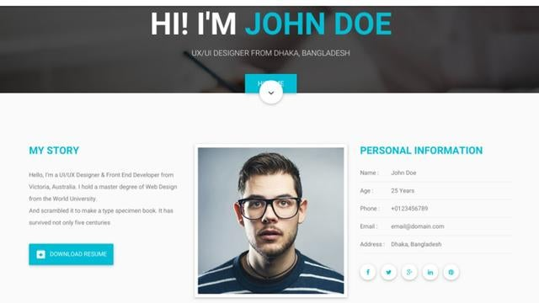**Output**:-